Project Application Form
Please read and fill in this form carefully. This format and the information it must contain are required for each proposal. Applications that do not stick to this format or lack the required information run the risk of getting disqualified right away. (The maximum number of pages to be 20).

- General Information

Title of The Project | The title of The Project should be short, concise and refer to the main objectives or activities of project
Project geographic area | The area where The Project will be implemented
Thematic focus | □Monitoring the implementation of child rights  □Preventative and protective community based services  □Provision of specialized services for children victims of sexual abuse, exploitation and trafficking  □Accountability mechanism in case management  □Advocacy at local and national level for child rights implementation  □Awareness raising and communication plan at the local level involving community and youth groups  □Support the implementation through outreach work to reach targeted children, ensuring access, referral mechanism
Beneficiaries
Name of the applicant(s)
Full address of the applicant(s)
- Postal Address
- Telephone
- Fax
- E-mail
- Webpage
Contact person
- Position
- E-mail:
- Telephone:
Other Partners in the project, including a signed Partnership Agreement/if any

- Postal address
- Telephone
- Fax
- E-mail
- Webpage
Total estimated budget | amount
Amount requested from the SGS
Application date

- Project description:

- Make a brief description of your application by stating your request clearly and accurately. (Include information regarding the sector of focus, objectives, major activities, required funding, and the name/description of the area where the physical presence of the fund will be).

- Project justification / Relevance

  - Describe the current situation. Write down the needs and problems that must be solved through the required fund. (provide statistic data if possible);
  - Refer to any significant plans undertaken at national, regional and/or local level relevant to the action and describe how the action will relate to such plans;
  - Describe the relevance of the action to the objective(s) and priority (ies) of the call for proposals. Please try to give detailed explanation?

- Description of the target group:

- Describe and define the target groups and final beneficiaries, their needs and constraints, and state how the action will address these needs;
- Give a description of each of the target groups and final beneficiaries (quantified where possible).

- Goal and specific objectives:

- What do you expect to achieve through this project?

- Expected results:
- Explain the specific results expected stating how the action will improve the situation of the target groups and final beneficiaries. What would be the final impact for you;

- Detailed description of project activities:
- Identify and describe in detail each activity to be undertaken to produce results, justifying the choice of activities and specifying the role of each partner in the activities. In particular, list any publications proposed.

- Methodology (large-size grants proposed actions only):
- The methods of implementation and rationale for such methodology;
- The procedures for follow up and internal/external evaluation;
- The role and participation in the action of the various actors and stakeholders, target groups, authorities, etc.):
- The organisational structure and the team proposed for the implementation of the action (by function: there is no need to include the names of individuals);
- The planned activities in order to ensure the visibility of the action.

- Activity plan:
- (Duration and indicative action plan for implementing the action).
- Logical framework (large-size grants proposed actions only):
- Fill in the Logical framework in the Annexes Chapter.
- Project sustainability (medium & large-size grants proposed actions only):
- Describe the expected impact of the action with quantified data where possible (will it lead to improved legislation, codes of conduct, methods, etc.?);
- Provide a brief risk analysis and contingency plan, including a range of risk types;
- Explain how the action will be made sustainable after completion. This may include necessary follow-up activities, built-in strategies, ownership, communication plan, etc.

- Budget
- Budget, amount requested from the SGS.
- Fill in the Budget Form in the Annexes Chapter.
- Information about the applicant:
- Describe briefly and clearly internal structure of your organization; your financial system and the management structure; experience in implementing other projects mentioning the project title, period, time, amount and donor. Please also provide a short profile of each project staff foreseen to be involved during project implementation.

Annex II

Budget Application Form

Budget Application Form | Year
Costs | Unit | # of units | Unit value  (EUR) | Total Cost  (EUR)
1. Human Resources
Subtotal Human Resources
2. Travel
Subtotal Travel |  |  |  | 0.00
3. Equipment and supplies
Subtotal Equipment and supplies |  |  |  | 0.00
4. Local office
Subtotal Local office
5. Other costs, services
Subtotal Other costs, services
6. Other
Subtotal Other
7. Total eligible costs of the Action (1+6)

Annex III
Logical Framework
 | Intervention logic | Objectively verifiable indicators of achievement | Sources and means of verification | Assumptions
Overall objectives | Please list them and number them.  What are the overall broader objectives to which the action will contribute?  O1 – "Title of objective 1"  O2 – Title of objective 2" | Please indicate a target value for each indicator in this column whenever possible.  What are the key indicators related to the overall objectives? | Please list the sources of verification for each indicator.  What are the sources of information for these indicators?
Specific objective | What specific objective is the action intended to achieve to contribute to the overall objectives?  SO – "Title of the specific objective" | Which indicators clearly show that the objective of the action has been achieved?  Please list the indicators as follows:  SO. "Indicator 1" : target value  SO. "Indicator 2" : target value  … | What are the sources of information that exist or can be collected? What are the methods required to get this information? | Which factors and conditions outside the Beneficiary's responsibility are necessary to achieve that objective? (external conditions) Which risks should be taken into consideration?
Expected results | Results are the outputs/outcomes helping to achieve the specific objective. What are the expected results?  R1 – "Title of result 1"  R2 – Title of result 2" | What are the indicators to measure whether and to what extent the action achieves the expected results?  Please list the indicators for each result, as follows:  1.1 "Indicator 1" : target value (R1)  1.2 "Indicator 2" : target value (R1)  1.3 ….  2.1 "Indicator 1" : target value (R2)  2.2 "Indicator 2" : target value (R2) | What are the sources of information for these indicators?  Ex:  Source 1 (Indicator 1.2, 2.3 etc)  Or Indicator 1.1: source 1  Indicator 1.2: source 1  … | What external conditions must be met to obtain the expected results on schedule?
Activities | What are the key activities to be carried out, to produce the expected results? (Group the activities by result and number them as follows:  A1.1 – "Title of activity 1" (R1)  A1.2 – Title of activity 2" (R1)  (sub activities may also be created A1.2.1 etc)  A2.1 – "Title of activity 1" (R2)  A2.2 – Title of activity 2" (R2) | Means:  What are the means required to implement these activities, e. g. staff, equipment, training, studies, supplies, operational facilities, etc. | What are the sources of information on action progress?  Costs  What are the action costs? How are they classified? (Breakdown in the Budget for the Action) | What preconditions must be met before the action starts? What conditions outside the Beneficiary’s direct control have to be met for the implementation of the planned activities?

Annex IV

Legal Entity General Information

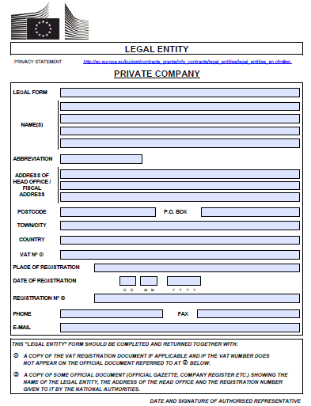

Annex V

Legal Entity Financial Information

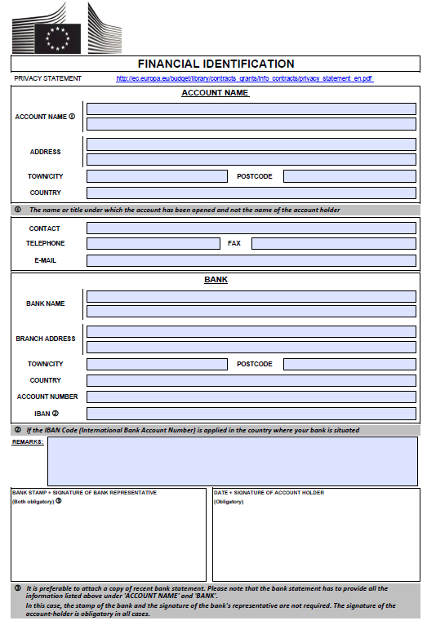

Annex VI

Payment Request for Grant Contract
European Union external actions
<Date of the payment request >
For the attention of
<Address of the Contracting Authority>
<Financial unit/section indicated in the Contract >
Reference number of the Grant Contract:
Title of the Grant Contract:
Name and address of the Coordinator:
Payment request number:
Period covered by the payment request:

Dear Sir/Madam,
I hereby request [a further pre-financing payment] [payment of the balance] under the Contract mentioned above.
The amount requested is <according to the option indicated in the Special Conditions of the Contract/the following: ...>.
Please find attached the following supporting documents:
- Expenditure verification report or detailed breakdown of expenditure ( if required by the General Conditions of the Contract)
- Financial guarantee (if required by the Special Conditions of the Contract)
- Narrative and financial interim report (for further pre-financing payments)
  - A forecast budget for the subsequent reporting period (for further pre-financing payments)
- Narrative and financial final report (for payment of the balance).
The payment should be made to the following bank account: <give the account number shown on the financial identification form annexed to the Contract>
Declaration on honour
I hereby certify that the information contained in this payment request is full, reliable and true, and is substantiated by adequate supporting documents that can be checked.
I hereby certify that the costs declared have been incurred in accordance with this Contract and that they can be considered as eligible in accordance with the Contract.
Yours faithfully,

< Signature >

Annex X
Declaration by the Applicant
The applicant, represented by the undersigned, being the authorised signatory of the applicant, in the context of the present call for proposals, representing any co-applicant(s), affiliated entity(ies) in the proposed action, hereby declares that
- The applicant has sufficient financial and organizational capacity to carry out the proposed action or work programme;
- The applicant certifies the legal statues of the applicant, of the co-applicant(s) and of the affiliated entity(ies) as reported in this Application;
- The applicant, the co-applicant(s) and the affiliated entity(ies) have the professional competences and qualifications specified in this Application;
- The applicant is directly responsible for the preparation, management and implementation of the action with the co-applicant(s) and affiliated entity(ies), if any, and is not acting as an intermediary;
- The applicant and the co-applicant(s) and the affiliated entity(ies) are not in any of the situations excluding them from participating in contracts. Furthermore, it is recognised and accepted that if the applicant, co-applicant(s) and affiliated entity(ies) (if any) participate in spite of being in any of these situations, they may be excluded from other procedures;
- The applicant and each co-applicant and affiliated entity (if any) is in a position to deliver immediately, upon request, the supporting documents stipulated in this Application.
- The applicant and each co-applicant and affiliated entity (if any) are eligible in accordance with the criteria set out in the Application;
- If recommended to be awarded a grant, the applicant, the co-applicant(s) and the affiliated entity(ies) accept the contractual conditions;
- The applicant, the co-applicant(s) and the affiliated entity(ies) are aware that, for the purposes of safeguarding the financial interests of the EU, their personal data may be transferred to internal audit services, to the European Court of Auditors, to the Financial Irregularities Panel or to the European Anti-Fraud Office.
- The applicant is fully aware of the obligation to inform without delay the Contracting Authority to which this application is submitted if the same application for funding made to other European Commission projects, European Union institutions or any other institutions (local, national or international) has been implemented/approved by them after the submission of this grant application.
The applicant acknowledges that if found guilty of misrepresentation of any of the above, it may be subject to immediate cancellation of the application.
Signed on behalf of the applicant
Name
Signature
Position
Date

Annex XI

Declaration by the Co-Applicant
This section must be completed for each co-applicant, if any. You must make as many copies of this table as necessary to create entries for each additional co-applicant.
Co-applicant no.1
Name of the organisation
The co-applicant’s contact details for the purpose of this action
Abbreviation
Registration number in the court (or equivalent)
Date of registration
Place of registration
Official address of registration
Website and E-mail address of the organisation if applicable
Telephone number: Country code + city code + number
Fax number: Country code + city code + number
The co-applicant(s) authorise the Applicant < XXXXXXXXXXXXXXXXX > to submit on their behalf the present application form for applicant, as well as, to be represented by the Applicant in all matters concerning this grant application.
I have read and approved the contents of the proposal submitted to the Contracting Authority. I undertake to comply with the principles of good partnership practice.
Name:
Organisation:
Position:
Signature:
Date and place:

Annex XII

Declaration of Vetting
This section must be completed by each Applicant and Co-Applicant, if any.
Full Name of the organisation
Date of registration
Place of registration
Official address of registration
Website and E-mail address of the organisation if applicable
Telephone number: Country code + city code + number
Fax number: Country code + city code + number
Full names of the key staff (Board of Directors and Country Director, including their date/year/place of birth

The applicant acknowledges that if found guilty of misrepresentation, it may be reason for the rejection of its application.

Name:
Organisation:
Position:
Signature:
Date and place:

